For this assignment by exception I chose alma Linux, because I have a problem with all openSUSE distributions on my virtualbox, which take more time that I can spend for debugging/solving it.   
I have experience with both systems from the previous LSA course, so switching is not a problem.

# TASK 1

Preparations:

6 disks (5GB each). The system must recognize them as sd{b..g}

lsblk

Since the both tasks are based on ZFS, First we have to add the repository, create zfs.conf and reboot the machine

Check if zfs is properly installed:

sudo modprobe zfs

sudo zfs version

If we want to have Key File to automount the pool we have to create it first and after that encrypted pool must be created

# create key file:

sudo mkdir -p /root/zfs-keys

sudo chmod 700 /root/zfs-keys

sudo dd if=/dev/urandom of=/root/zfs-keys/zfs.key bs=32 count=1

sudo chmod 600 /root/zfs-keys/zfs.key

# create encrypted pool (3x2):

sudo zpool create \

  -O encryption=on \

  -O keyformat=raw \

  -O keylocation=file:///root/zfs-keys/zfs.key \

  zfs-raid10-3x2 \

  mirror /dev/sd{b,c} \

  mirror /dev/sd{d,e} \

  mirror /dev/sd{f,g}

# for 2x3 is pretty much the same, but with two mirrors and zfs-raid10-2x3

# check

sudo zpool status

sudo zfs get encryption

Demo:

Video demo:

[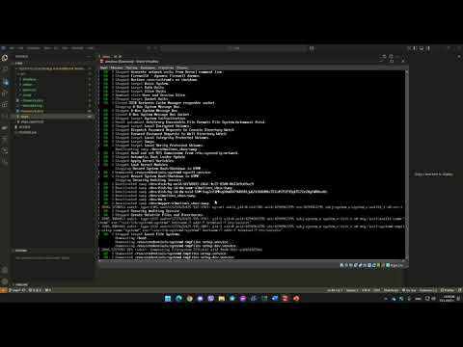](https://www.youtube.com/embed/QJmRQeYX6XA?feature=oembed)